Case Study:
Proteus Pro-System® Plus

Roof Refurbishment, Waterstones Piccadilly, London

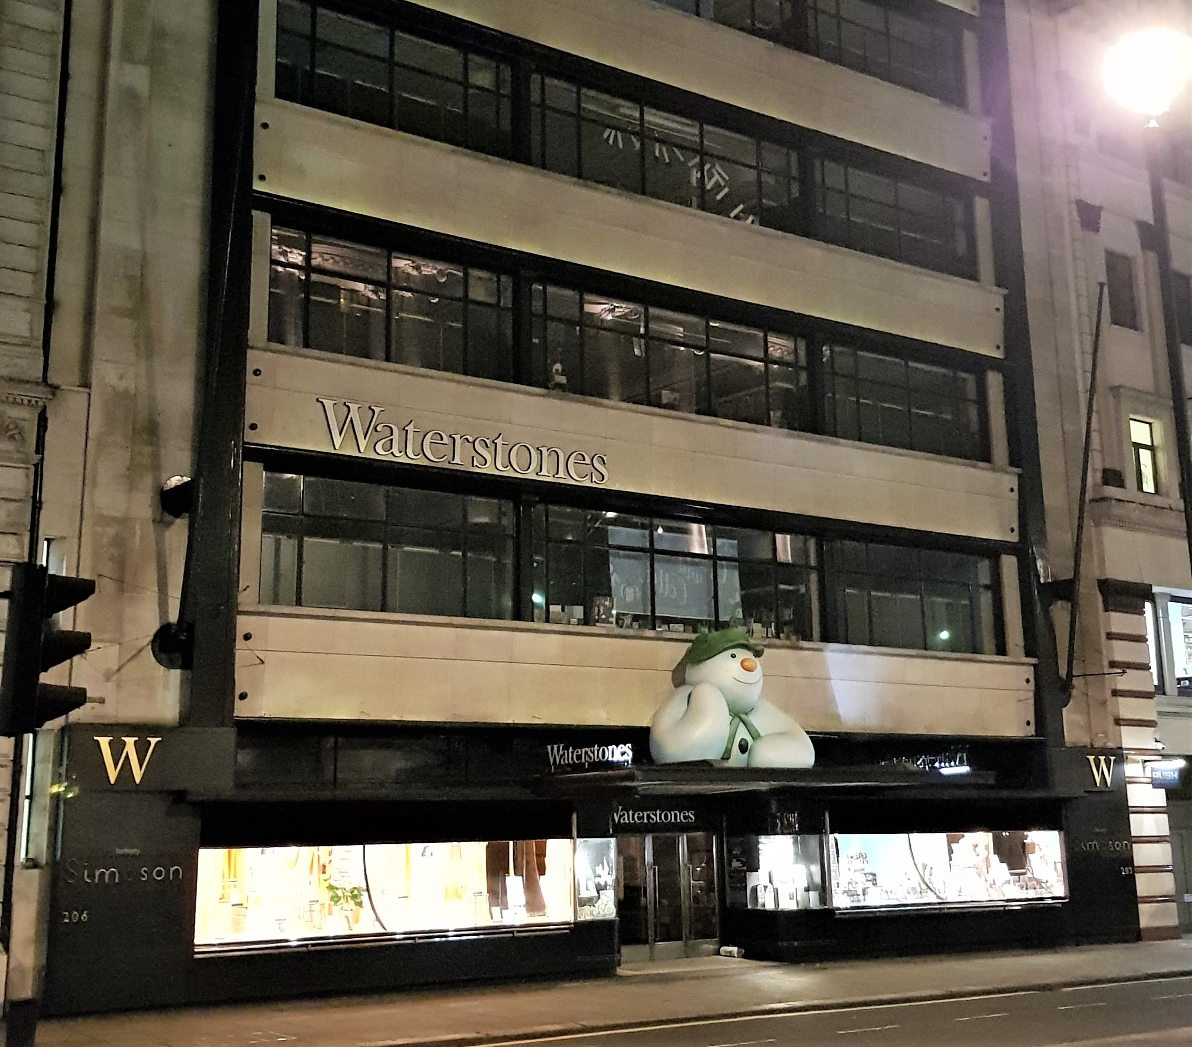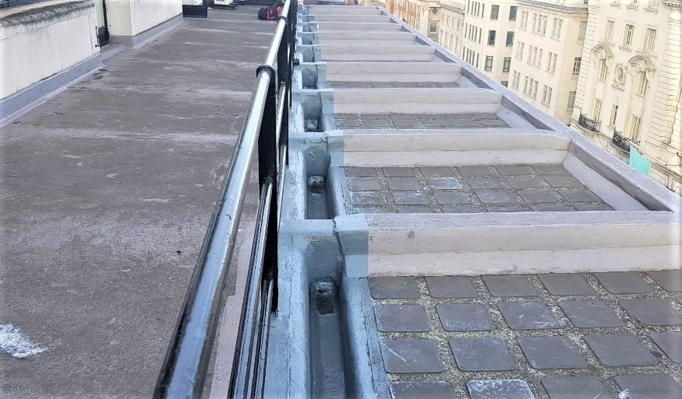

Project Brief:
Waterstones head office in Piccadilly required a new waterproofing system due to the existing membrane leaking. A guaranteed solution was required that could bond and be applied over the single ply membrane and accommodate awkward roof details.
Therefore, Proteus Pro-System® Plus, a cold applied liquid, seamless
membrane was specified.

Key Requirements: High Performance Waterproofing

The pitched roofs and gutters had previously been overlaid with a single ply membrane, however due to poor detailing, leaks had begun from the start. Localised repairs had also failed to cure the problem. After a roof survey, Proteus Waterproofing was able to present the client with the most cost-effective, robust waterproofing solution. Proteus Pro-System® Plus was specified as this fully reinforced polyurethane system offered the perfect waterproofing overlay solution for this refurbishment project.

Key Requirements: Health & Safety:

When working on occupied buildings, particularly retail, safety, low impact and noise is always of the utmost importance. As Proteus Pro-System® Plus is cold install and low odour it met all the health and safety criteria to work on these occupied buildings. It also kept disruptions to employees and members of the public to a minimum, which ensure the store was able to continue trading.
Proteus Waterproofing worked closely with the Proteus Approved Contractor, Chrysalis Refurbishment Ltd. to ensure the project was completed to a high standard, by regular site visits during the application process and ongoing advice.

Key Requirements: Long Term Performance:
Proteus Pro-System® Plus offers a low maintenance, durable waterproofing and protection solution for a range of new build and refurbishment applications. It is cold applied, which eliminates the risk of fire and once cured, provides a completely seamless waterproof protection and has excellent thermal and UV stability, making it suitable to use in all climates. Proteus ProSystem® Plus has a quick and straightforward application, and is BBA Certified.

Proteus Industrial Technologies Ltd.
21a Sirdar Road
Brook Road Industrial Estate Rayleigh
Essex SS6 7XF
Tel: 01268 777871
Fax: 0845 2991215
Email: office@proteuswaterproofing.co.uk
www.proteuswaterproofing.co.uk

Registered Office: 21a Sirdar Road, Brook Road Industrial Estate, Rayleigh, Essex. SS6 7XF | Registered company number: 08258719

